1. Go to the boot volume (block storage > boot volume)

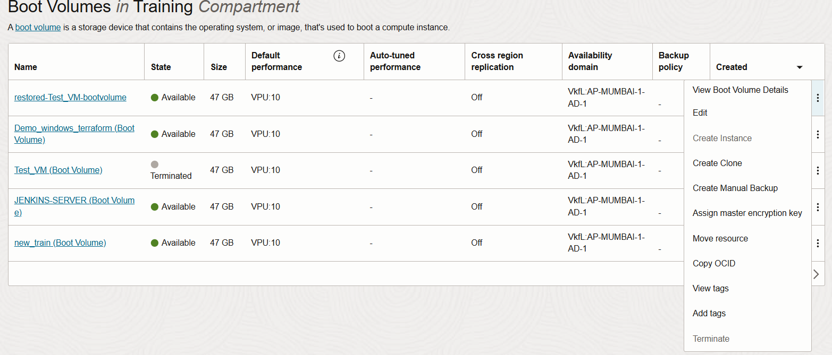2. Select the VM and select create manual backup for that VM

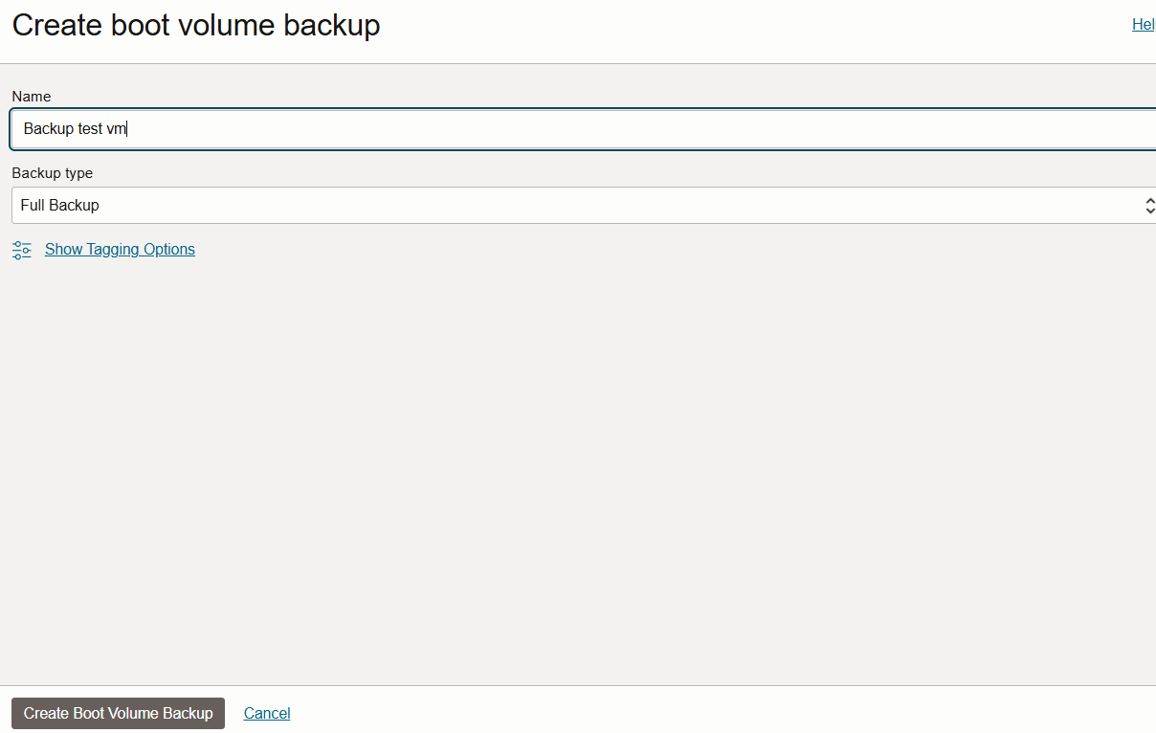3. Give name for the backup file and create backup

4. wait till the backup is created

5. Go to the instance – select VM and in action click terminate

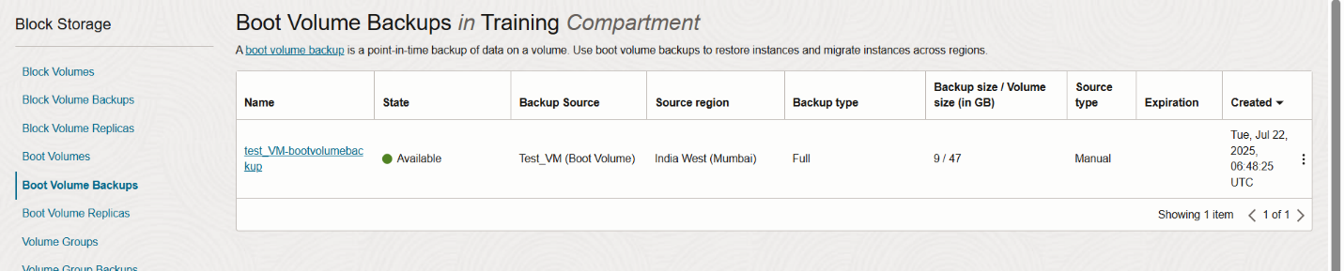6. Now go to Boot volume backup section (block storage > boot volume backup)

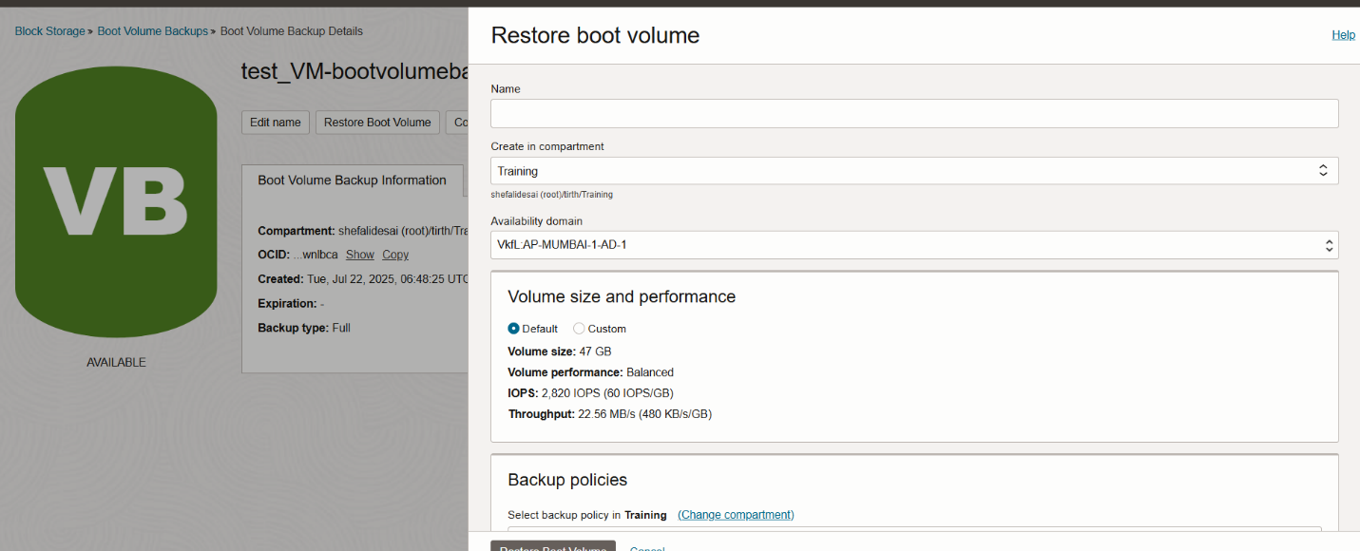7. Restore the boot volume and give name to it as per convenience (eg. Restored-VM)

8. Now go to compute instance and create instance

9. Give name to instance

10. In image and shape select my image > boot volume > select your restored boot volume

11. Config rest all as before and upload the public key of the original VM in network section

12. Connect to terminal with SSH with the same original key

13. If it does not work than add the original public key to the console connection in new(restored) VM

VM>OS management>Console Connection

14. Now try again

15. Now attach the previous Block volume to the new instance

16. Discover and connect the iSCSI volume

17. Run mount -a to mount everything in fstab

18. now your all files are visible